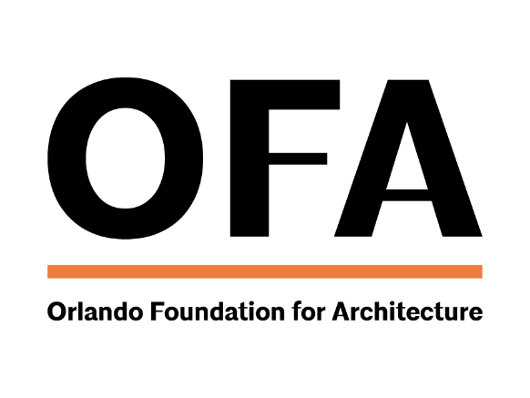
SPONSORSHIP OUTREACH TEMPLATE
(PREVIOUS SPONSORS)

Dear (SPONSOR),

It’s time to start planning for the (EVENT NAME)! We’re so thankful for your support and sponsorship of our previous event and want you to be the first to know about these available opportunities. All event information, sponsorship levels and benefits can be found on the event page of our website: (EVENT PAGE LINK).

This year’s event will be held on (DATE AND LOCATION) and our supporters will be recognized for their outstanding contributions to the Central Florida architecture & design community. This is your opportunity to showcase your brand and build your network in front of architects, designers, firms and allied professionals.

We hope you’re excited to be involved again this year—your support is very much appreciated!

For more information and questions, please contact (LIAISON’S EMAIL)

